Exploring the Grantmaker’s Role in Structuring Engagements Across Grantees: Peer Learning & Networks
Summer 2020 SREE & Ascendium Summer Research Fellowship
Rachel Williams

Overview
This project explores the literature on grantmaking strategies designed to facilitate peer learning, collaboration, and coordination across grantees. Funders are in the unique position to identify and connect the landscape of organizations working at the nexus of fields, sectors, and issue areas. Many funders have experimented with ways to develop an infrastructure to formalize opportunities for their grantees to learn and collaborate with one another. This project synthesizes the affordances and critical design features of cohort grantmaking through a review of the literature. Then, communities of practice and network cultivation are explored as potential frameworks and approaches to designing grantmaking strategies that center peer learning and connectivity. The project concludes with five lessons and themes from three interviews with grantmakers implementing cohort or similar strategies. This project provides grantmakers with a review of the literature on cohort grantmaking and other relevant frameworks that can strengthen the funder’s impact and objectives by building the capacity of grantees to advance their individual mission or increasing the coordination of many grantees working at the nexus of fields, sectors, or issue areas.
Cohort strategies are typically designed to provide peer learning across grantees to strengthen the capacity of individual organizations to advance their mission or as a mechanism to support skill building for a collaborative project. The structure of cohort grantmaking can vary from ongoing, optional programming for existing multi-year grantees; a new cohort-based multi-year grant program; or short-term capacity-building programming for a collaborative project. Throughout the literature, critical design features emerged that were linked to positive implementation of cohort grantmaking strategies. In what follows, the design features from the literature are briefly discussed.

Key Findings
- Co-Construct Program Design & Learning Opportunities with Grantees. The design of cohort programming typically emerges from evaluations or one on one discussions with previous or current grantees. Many capacity-building cohort-based programs developed based on patterns, feedback, and themes that emerged from traditional grantmaking (Devine, 2016; Francis et al., 2018). Funders considering cohort grantmaking can begin by exploring feedback from previous grantees about the potential value of peer learning as well as any common themes related to organizational challenges that provide insights on potential content areas that may resonate with grantees for future peer learning opportunities. Additionally, funders report positive participant outcomes when the substance and content of programming is co-constructed with grantees (Francis et al., 2018; Packard, 2018; Reich, 2018)
- Organizational Readiness Translates to Impact. Grantees whose leaders previously committed to improving financial capacity prior to cohort grant program achieved higher levels of progress on best-practice indicators, suggesting that organizational commitment to improve the content area may be important to assess as a readiness factor that meaningfully translates to the implementation of cohort-based capacity building training (Devine, 2016). Funders assess readiness by changing the request for proposals process or developing strategic goals and extending invitations to selected grantees (Francis et al., 2018; Reich, 2018).
- Implement Strategies for Sustained Cohort Engagement. Funders reported that sustained engagement beyond the grant cycle was more likely to occur when organizations worked in geographic proximity (Packard, 2018) and evaluations evidenced that geographic clusters helped cultivate a sense of collective work and resulted in a network to a greater extent than a non-regional focus (Taddy-Sandino et al., 2019). In addition to geography, utilizing field-specific gatherings as cohort engagement opportunities and collaborative approaches as the capacity-building focus (e.g., collective impact training) are levers to structure cohorts to sustain relationships beyond funder organized convenings.
- Maximize Virtual Programming with Certain Conditions. The value and affordances of in-person meetings resonates even in the context of well-designed virtual cohort programming (Bradley et al., 2017). However, the affordances of virtual programming can be maximized under certain conditions: synchronous meetings; small groups with stable participants; and trained facilitators to establish and facilitate virtual group culture (Bradley et al., 2017). The key to maximizing virtual platforms is about structuring the setting for interaction and relationship cultivation.
- Funding Shapes Impact. Cohort grantmaking requires funding considerations that can support impact. Through the implementation and evaluation of the two models, a foundation learned that group training and coaching with a lower funding threshold is just as effective in building capacity as individualized training with higher levels of financial support, suggesting that the group learning environment may facilitate similar outcomes with lower financial support (Devine, 2016). However, other studies illuminate that the expected deliverables of cohort initiatives must be in proportion to the financial grants and technical assistance must adequately align with the goals of the group purpose or deliverable (Lee & Calvin, 2006).

Conceptual Approaches
Communities of practice and network cultivation offers grantmakers conceptual approaches that can be applied to cohort grantmaking strategies. As funders consider ways to structure and cultivate peer learning opportunities, a communities of practice approach can provide useful insights to guide the development of peer learning opportunities. Communities of practice is a concept that emerged out of social learning theory that refers to the development of sustained learning group based on a collective intention to advance learning in a particular domain (Wenger, Trayner, & De Laat, 2011). The communities of practice approach have been leveraged in a number of settings such academe, business, government, education, and healthcare sector (Wenger, 2012). Establishing a community of practice requires
Networks are typically structured to optimize connectivity for the affordances of learning, linkages, problem solving, and knowledge creation. A key distinction between funders interested in cultivating communities of practice or cohort-based capacity building and funders interested in cultivating networks is the emphasis on coordination and collaboration. Funders can leverage the affordances of networks to resolve challenges that emerge in prioritized fields. Networks are particularly useful for structuring connections across key actors nationally for learning and coordination, particularly for actors working on similar issues in different states. However, to the extent that philanthropy funds initiatives in ways that activates networks that result in disproportionate influence in a field, limits on the political empowerment of those most impacted by the issue may be an unintended consequence (Scott, 2009; Reckhow & Snyder, 2013).

Interview Findings
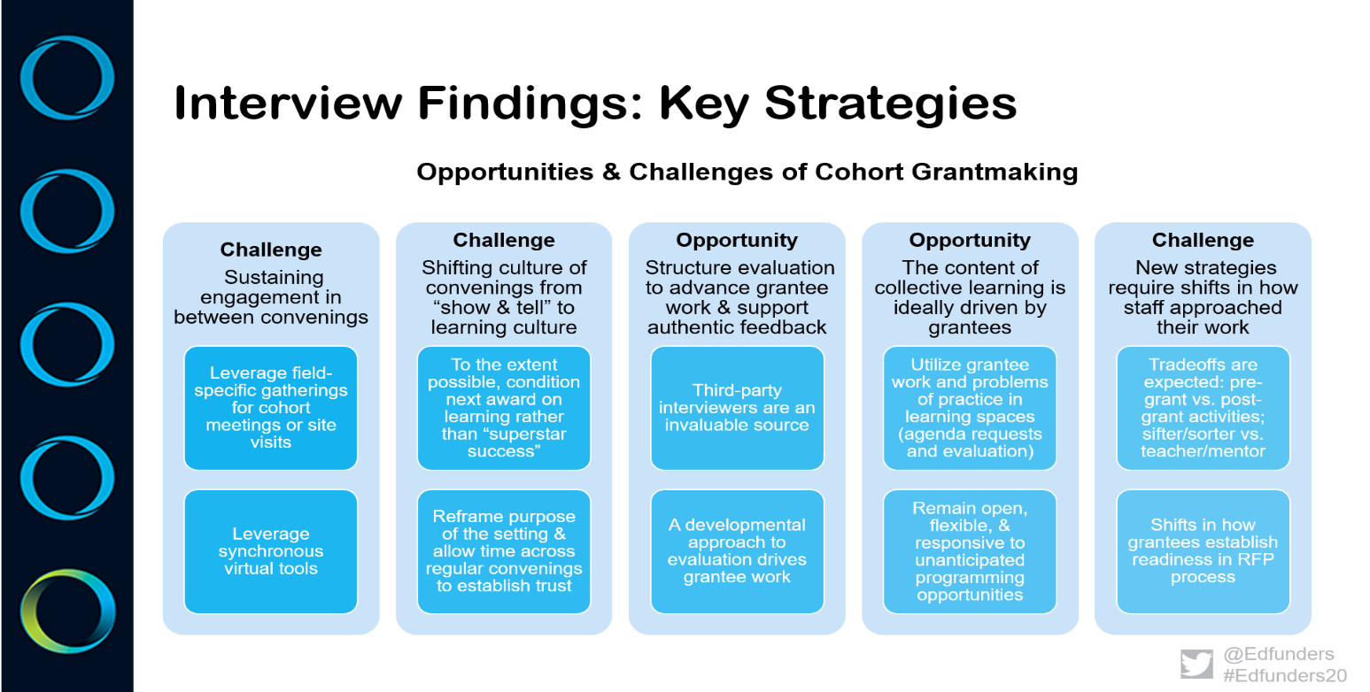

This graphic provides an overview of key themes and insights from three interviews with foundation leaders implementing grantmaking strategies that support learning and collaboration across a group of grantees. The summary of themes provides a reference for grantmakers exploring strategies to structure learning and collaboration across grantees.

Conclusion
As funders explore ways to structure engagements across grantees, the literature on cohort grantmaking, communities of practice, and networks provides insights on critical design features and conceptual approaches that can translate into strengthened grantee capacity and increased funder impact. Cohort grantmaking has the potential to strengthen the capacity of grantees to advance their missions and foster the collaboration and coordination of many grantees working at the nexus of a field, sector, or issue area. Funders increase the impact of their missions and funding priorities by expanding grantmaking activities to support grantees by building the infrastructure for opportunities for capacity-building, collaboration, and coordination. This paper provides a resource for grantmakers exploring ways to design these opportunities and continuously improve their grantmaking strategies.
References
Bradley, K., Chibber, K. S., Cozier, N., Vander Meulen, P., & Ayres-Griffin, C. (2017). Building healthy start grantees’ capacity to achieve collective impact: Lessons from the field. Maternal and child health journal, 21(1), 32-39.
Devine, N. (2016). The groundwork for successful cohort-based fiscal capacity-building: An evaluation of the Strengthening Financial Management Initiative. The Foundation Review, 8(1), 6.
Francis, M., Desmond, C., Williams, J., Chubinski, J., Zimmerman, J., & Young, A. (2018). Thriving communities: A model for community-engaged grantmaking. The Foundation Review, 10(4), 9.
Lee, K. S., & Calvin, J. R. (2006). Stronger relationships, stronger communities: Lessons from a regional intergroup grant initiative. American journal of community psychology, 37(3-4), 275-282.
Nolan, C., Souza, B., Monopoli, M., & Hughes, M. (2017). Funders as network strategists, weavers, and managers: Learning from one foundation’s journey and results. The Foundation Review, 9(2), 5.
Packard Foundation. (2018). Building Capacity Through Cohorts: What the Packard Foundation is Learning. Retrieved from https://www.packard.org/insights/resource/building-capacity-through-cohorts-what-the-packard-foundation-is-learning/
Reckhow, S., & Snyder, J. W. (2014). The expanding role of philanthropy in education politics. Educational Researcher, 43(4), 186-195.
Reich (2018). Changing grantmaking to change the world: Reflecting on BUILD’s first year. Retrieved from https://philanthropynewsdigest.org/connections/changing-grant-making-to-change-the-world-reflecting-on-build-s-first-year
Searce, D. (2011). Catalyzing networks for social change: A funders guide. Retrieved from Grantmakers for Effective Organizations & the Monitor Institute website: https://www.geofunders.org/resources/catalyzing-networks-for-social-change-a-funder-s-guide-685
Scott, J. (2009). The politics of venture philanthropy in charter school policy and advocacy. Educational Policy, 23(1), 106-136.
Taddy-Sandino, S., Gray, M., & Scaturro, D. (2019). Learning together: cohort-based capacity building and the ripple effects of collaboration. The Foundation Review, 11(2), 7
Wenger, E., McDermott, R. A., & Snyder, W. (2002). Cultivating communities of practice: A guide to managing knowledge. Harvard Business Press.

